**Sampling Theory: Test of Hypothesis:**

**Sampling Theory and Hypothesis Testing**

**Sampling Theory** is a branch of statistics that deals with selecting a subset of individuals or observations from a larger population to make inferences about the population. In **hypothesis testing within sampling theory**, we aim to make decisions about population parameters based on sample data.

**1. Importance of Sampling in Hypothesis Testing**

Sampling allows us to:

* Draw conclusions about a population without examining every individual.
* Reduce the cost, time, and effort required for data collection.
* Perform hypothesis testing using manageable sample sizes while still maintaining statistically significant results.

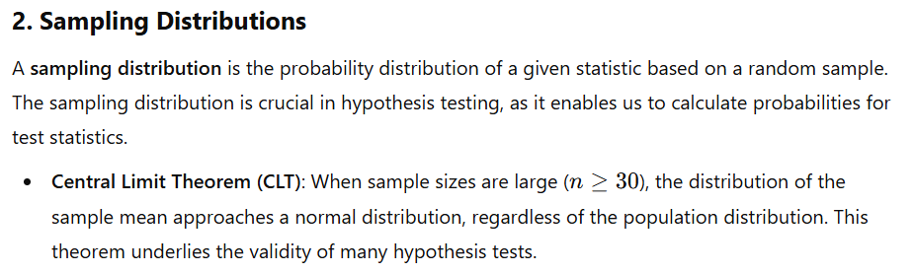

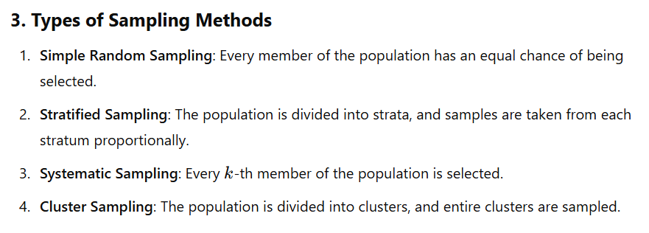

**4. Hypothesis Testing Framework in Sampling Theory**

In sampling theory, hypothesis testing aims to determine if there’s enough evidence in the sample to support a hypothesis about a population parameter.

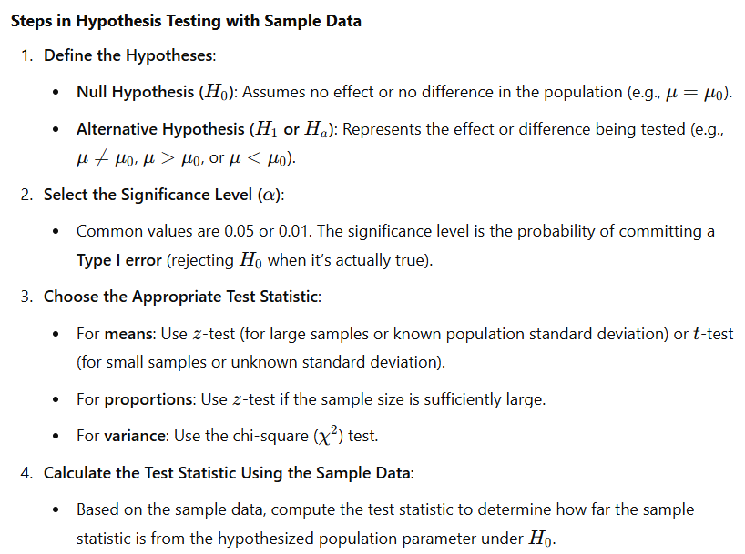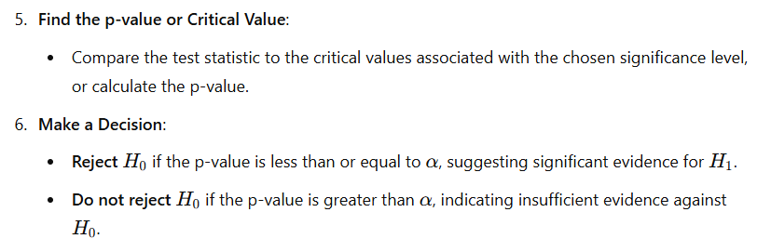

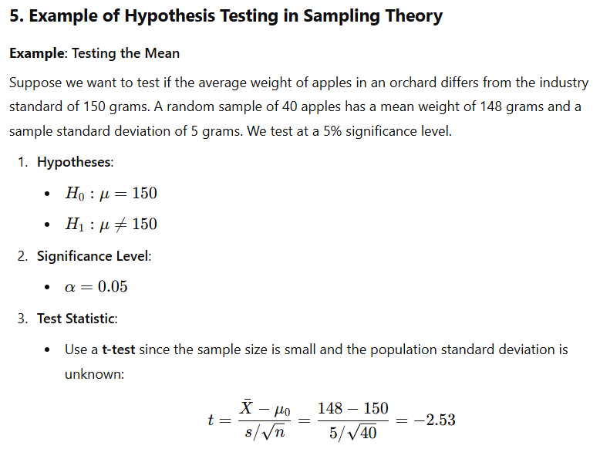

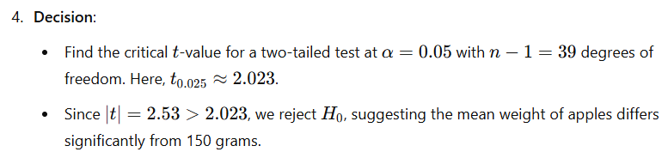

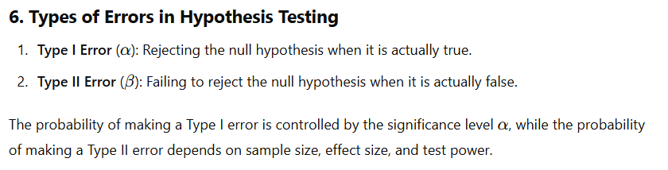

**7. Applications of Hypothesis Testing in Sampling Theory**

* **Quality Control**: Sampling batches to determine if they meet product standards.
* **Polls and Surveys**: Estimating population opinions or characteristics from a sample.
* **Medical Studies**: Testing the effectiveness of treatments using samples of patients.

Sampling theory and hypothesis testing are essential for making informed decisions based on incomplete data, allowing conclusions about a population to be drawn from sample information with controlled error rates.

**Level of significance:**

**Level of Significance**

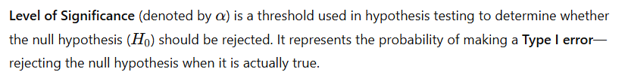

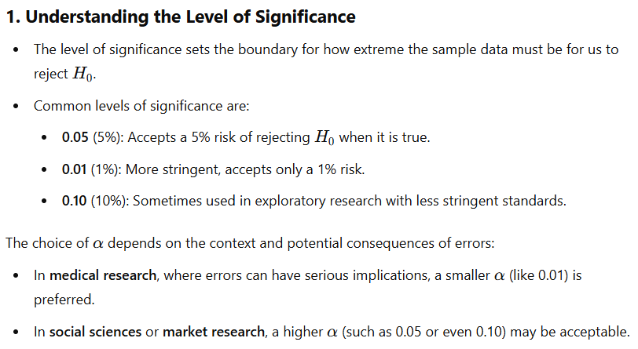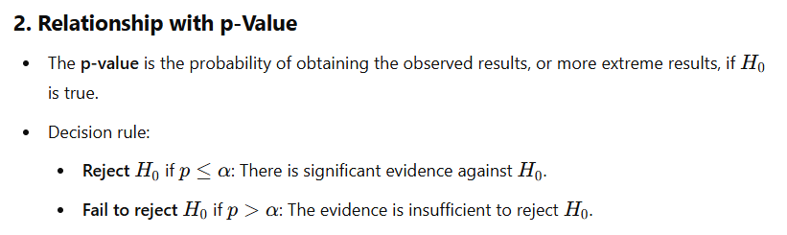

**3. Example of Level of Significance in Hypothesis Testing**

Suppose a researcher wants to test if a new drug is effective in reducing blood pressure compared to a placebo.

* **Null Hypothesis (H0H_0H0​)**: The drug has no effect on blood pressure (mean difference = 0).
* **Alternative Hypothesis (H1H_1H1​)**: The drug reduces blood pressure (mean difference < 0).
* The researcher sets α=0.05\alpha = 0.05α=0.05.

If the test produces a **p-value** of 0.03:

* Since p=0.03<α=0.05p = 0.03 < \alpha = 0.05p=0.03<α=0.05, the null hypothesis is rejected.
* This suggests there is statistically significant evidence at the 5% level that the drug reduces blood pressure.

**4. Trade-Offs and Errors**

* **Type I Error (False Positive)**: Occurs if H0H_0H0​ is rejected when it is true. The probability of this error is α\alphaα.
* **Type II Error (False Negative)**: Failing to reject H0H_0H0​ when H1H_1H1​ is true, with probability denoted by β\betaβ.
  + Lowering α\alphaα reduces the risk of a Type I error but increases the risk of a Type II error, and vice versa.

**5. Choosing an Appropriate Level of Significance**

The significance level should reflect the context and the acceptable risk of error:

* **Higher stakes** (e.g., medical trials): A smaller α\alphaα reduces the chance of incorrectly concluding the treatment works.
* **Lower stakes** (e.g., preliminary research): A larger α\alphaα might be chosen to detect potential effects without stringent error controls.

In hypothesis testing, the level of significance serves as a pre-defined standard for decision-making, balancing the need for evidence with the consequences of errors.